Physics 30 Lesson 33   
Wave–Particle Nature of Light and Matter

Many centuries ago, especially in the time of Isaac Newton and Christian Huygens, there was an intense debate over the nature of light. Newton argued for a corpuscular (i.e. small particle) theory of light, while Huygens championed the wave theory of light. Different observations of the properties of light supported different theories. The observation that light rays travel in straight lines lends support to a corpuscular idea, while the spreading of light from a source in all directions, like a candle, may be visualised as a wave. The debate was seemingly resolved in the early 18th century when, as we saw in Lessons 11 and 12, Young demonstrated that light exhibited interference properties which clearly show that light is a wave.

However, a wave theory of light is not able to explain other phenomena. While a wave-like description of light explains the diffraction and interference of light, the application of a quantum, particle-like conception of light (i.e. photons) is required to explain such phenomena as the photoelectric effect (Lesson 29), emission and absorption spectra (Lesson 30), and gamma radiation (see Lesson 35). So it seems that light can be thought of as a particle and as a wave, but which is correct? The answer is, both are correct. Light is both wave and particle at the same time and the properties that we observe depend (a) on the energy (E = hf) of the light and (b) on the kind of experiment we decide to conduct. Generally speaking, the more energetic the photon, the more particle-like its behaviour will be. Consider the electromagnetic (light) spectrum:

frequency (Hz)

102

1022

1018

106

1010

1014

gamma ray

UV

IR

radio waves

x-ray

visible

For high frequency, high energy light the particle nature of light dominates.

For low frequency, low energy light the wave nature of light dominates.

Notice that the overlap between dominant particle and wave nature occurs for light that we as humans can see. Therefore, the wave-like or particle-like behaviour of light depends on the particular phenomenon that we are investigating.

# Wavelengths of matter

[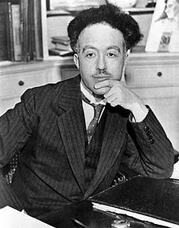](http://en.wikipedia.org/wiki/Image:Broglie_Big.jpg)Louis de Broglie was educated in history at the Sorbonne. After serving in World War I in the field of communications he returned to the Sorbonne to study science. He became interested in the work of Compton and began to study the wave-particle duality of nature. His work earned him the 1929 Nobel Prize for Physics.

When Compton had suggested through his x-ray scattering experiments that light photons had particle-like characteristics, de Broglie wondered if the **converse** was true – could subatomic particles like the electron behave like a wave? De Broglie sought an expression for the wavelength that might be associated with wave-like behavior of an electron, the smallest known particle at the time. The **momentum of a particle** (Lesson 1) is given by

p = m v

The **momentum of a photon** (Lesson 32) is given by



By equating the two relationships we get



re-arranging the equation we get de Broglie’s wavelength formula



If de Broglie’s wavelength formula was correct, then an electron should demonstrate some wavelike characteristics. Moreover, as the speed of the electron became larger, its wavelength should be shorter.

What is the wavelength associated with an electron moving at half the speed of light?



If an electron is allowed to accelerate through a potential difference of 100 V, what is its de Broglie wavelength?

first find the speed (v) of the electron

Ep = EK

q V = ½ m v2

 = 5.93 x 106 m/s

using the de Broglie wavelength formula

 = **1.23 x 10-10 m**

Since diffraction was the easiest phenomena to demonstrate the wavelike nature of something, Young had done so for light in 1804, de Broglie and his associates began to find some way to demonstrate the diffraction of electrons. Refer to Pearson pages 782 to 783.

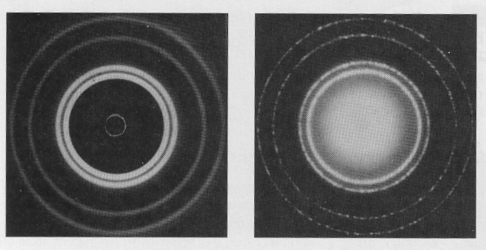

**x-ray** diffraction pattern from aluminum foil

**electron** diffraction pattern from aluminum foil

According to Fresnel’s wave theory, in order to observe diffraction the wavelike electrons must pass through a gap proportional to the wavelength. Such “gaps” are found between atoms in a crystal structure. In 1923 C.J. Davisson and L.H. Germer successfully demonstrated the diffraction of electrons through a crystal of nickel. In 1927, G.P. Thomson, son of J.J. Thomson, obtained diffraction of electrons through a gold foil. Both of these experiments confirmed that electrons display wave characteristics.

So why don’t moving objects in our everyday experience demonstrate wavelike behavior? If we use a 1.00 kg mass traveling at 10.0 m/s, de Broglie’s equation gives us a wavelength of

 = **6.63 x 10-33 m**

This wavelength is far too small to be seen in the everyday world of objects. Therefore, we are not aware of the wave nature of everyday material objects.

# Orbiting electron waves

Louis de Broglie now began to apply the wave nature of the electron to the electrons orbiting around hydrogen nuclei. Assuming that the electron acts like a wave in the hydrogen atom rather than a particle, de Broglie began to try to fit his wavelength into a circle. The electron acts like a **standing wave** spread over an orbit (circle) of radius (r).

standing wave in one dimension

two dimensional standing wave

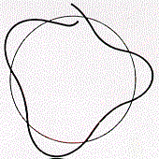

Some wavelengths fit and some do not. When a wave does not constructively close, it interferes with itself and rapidly dies out (illustration on the right).

Only waves that constructively interfere are stable. Some standing circular waves for two, three and four wavelengths on the circumference of a circle are illustrated below.

these lines are meant to illustrate the vibratory nature of the wave

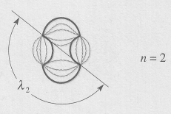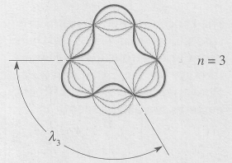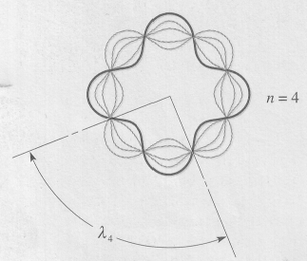

De Broglie found that the conditions for a proper fit can be expressed as an equation. Since the circumference equals 2  r and n equals whole number values of wavelengths …

2  r = n 

rearranging slightly



Combined with de Broglie’s wavelength equation



we get



or 

Amazingly, this is the mathematical form of one of Bohr’s postulates: **An electron can only have certain discrete, stationary orbits**. De Broglie’s relationship for the electron acting like a wave in an orbit allows us to derive Bohr’s quantized equation where n is Bohr’s primary quantum number for the energy level of the electron. Further, the idea that electrons within an atom behave as waves rather than as orbiting particles explains why they do not continuously radiate electromagnetic energy.

If the wavelength for an electron in an atom is 2.0 x 10-10 m, what is the **smallest** allowable orbital radius for this electron?

2  r = n  (n = 1)

 = **3.18 x 10-11 m**

Louis de Broglie checked his idea by substituting Bohr’s energy of the electron in the first energy level of hydrogen (13.6 eV) into his standing wave relationship.

First, convert 13.6 eV to Joules

E1 = 13.6 eV x 1.6 x 10-19 J/eV = 2.176 x 10-18 J

Now find the speed of the electron in the first energy level orbit

= 2.187 x 106 m/s

Then find the associated radius for the first energy level (n = 1) from equation (3) above

 = **5.3 x 10-11 m**

We get the same radius that Bohr calculated for his hydrogen orbit.

# Double-slit interference of particle waves

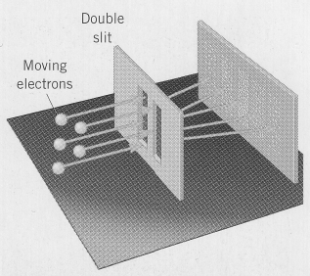The de Broglie equation for particle wavelength provides no hint as to what kind of wave is associated with a particle of matter. To gain some insight into the nature of this wave, an electron version of Young's double-slit experiment was conducted in 1988-89 by A. Tonomura, J. Endo, T. Mat­suda, and T. Kawasaki. When a beam of electrons (i.e. thousands of them per second) pass through the double-slits, bright fringes occur in places on the screen where particle waves coming from each slit interfere constructively, while dark fringes occur in places where the particle waves interfere destructively.

At this point, Tonomura and his team changed the experiment. Instead of sending thousands of electrons through the slits, they sent **one electron at a time through one of the slits**. The picture above illustrates Tonomura’s apparatus. When an electron passes through the double-slit arrangement and strikes a spot on the screen, the screen glows at that spot. As more and more electrons strike the screen, the spots eventually form the fringe pattern that is evident when a beam of electrons is sent through both slits. Here lies the key to understand­ing particle waves. In 1926, the German physicist Max Born had suggested that the wave nature of particles is best understood as a measure of the probability that the particles will be found at a particular location. Bright fringes occur where there is a high prob­ability of electrons striking the screen, and dark fringes occur where there is a low probability. **Particle waves are waves of probability**. The fact that no fringe pattern is apparent after 100 or even 3000 electrons does not mean that there are no probability waves present, it means that the char­acteristic fringe pattern becomes recog­nizable only after a sufficient number of electrons have struck the screen. This measure of probability of a particle’s location is called **quantum indeterminacy**. This concept is the most pro­found difference between quantum physics and classical physics. According to quantum physics, nature does not always do exactly the same thing for the same set of conditions. Instead, the future develops probabilistically, and quantum physics is the science that allows us to predict the possible range of events that may occur.

after 3000 electrons

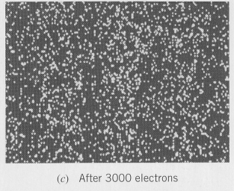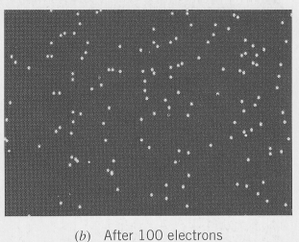

after 100 electrons

after 70 000 electrons

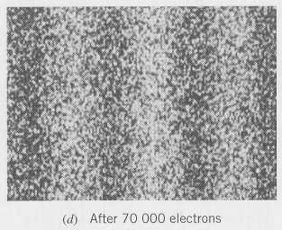

But there is another even more bazaar part of this experi­ment. When a **single-slit** is used for either light or electrons the interference pattern is different from the pattern produced for a double-slit apparatus. Thus, when a beam of electrons is sent through a single-slit the resulting pattern is different from when the electron beam is sent through a double-slit. However, when electrons are sent one at a time through a single-slit, the single-slit interference pattern emerges after a sufficient number of electrons have struck the screen. So far, so good. When another slit is added to the apparatus and electrons are sent through only one of the slits one at a time you would “expect” that a single-slit pattern would emerge since no electrons go through the other slit. But this is not the case. When the second slit is added the pattern becomes a double-slit interference pattern. How do the electrons “know” that there is another slit? Welcome to the weird world of quantum mechanics. (Refer to Pearson pages 737 to 740 and 782 to 784.)

Thus, de Broglie’s work allows us to consider the electron in the atom as a particle moving in an orbit with a certain quantized value of (m v r), or as a standing de Broglie type electron wave occupying a certain region around the nucleus. In 1925 the Austrian physicist Erwin Schrödinger (1887-1961) and the German physicist Werner Heisenberg (1901-1976) independently developed theoretical frameworks for determining the wave functions of electrons in atoms. Schrödinger would assume the electron **acts like a wave**, while Heisenberg would assume that the electron **acts like a particle** to develop his model of the atom. Later it would be shown that both models were equivalent. In so doing, they established a new branch of physics called **quantum mechanics**. The word “quantum” refers to the fact that in the world of the atom, where particle waves must be considered, the par­ticle energy is quantized, so only certain energies are allowed. To understand the structure of the atom and the phenomena related to it, quantum mechanics is essen­tial and the Schrödinger equation for calculating the wave function is now widely used. In the next lesson we will explore the structure of the atom based on the ideas of quantum mechanics.

# The Heisenberg uncertainty principle (optional reading)

[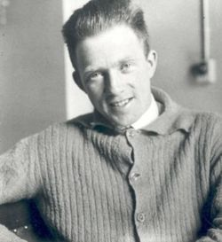](http://en.wikipedia.org/wiki/Image:180px-Werner_Heisenberg.jpg)Werner Heisenberg (1901-1976) was born in Würzberg, Germany. He received a PhD in physics in 1923 and worked under Max Born and Neils Bohr for a short period of time. He received the Nobel prize for physics in 1932. During the war he worked for the German atomic bomb project. After the war he was the head of the Max Planck Institute in Göttingen.

In 1927, Heisenberg formulated the **uncertainty principle**. In the uncertainty principle, Heisenberg struggles with our inability to see or know much about the electron. The study of the electron poses a problem: We cannot see what the electron is doing without changing what it is doing. To accurately know the position of an electron, it must be observed with external electromagnetic radiation. But the external radiation causes the momentum of the electron to change. Thus, in order to accurately know the speed of the electron or its momentum we will lose information about where it was, its location. Conversely, if we wish to know its position to a high degree of accuracy, we will lose information about its momentum. In other words, we cannot look at electrons without changing what they are doing.

Heisenberg summed his finding up in the **Uncertainty Principle** which is one sentence long but was also supported by hundreds of pages of mathematics.

We are unable to measure **both** the **position** and the **momentum** of an electron to unlimited accuracy.

An EMR source of small wavelength will give us accurate position but a large momentum kick (p = h/) . A long wavelength EMR source will give us a small momentum kick but terrible accuracy in position. Mathematically the relationship reads



where  x is the uncertainty in position

 p is the uncertainty in momentum

h is Planck’s constant

For an electron traveling at 2.0 x 106 m/s, if a 10% error exists in the measurement of the speed, what is the corresponding uncertainty in the position of the electron?

p = m v = 9.11x10-31kg (2.0 x 106m/s) = 1.82 x 10 –24 kg m/s

 p = 0.10 p = 0.10 (1.82 x 10 –24 kg m/s) = 1.82 x 10 –25 kg m/s

**2.9 x 10-10 m**

This error is very large. In sub atomic terms the electron could be in the next atom.

Why don’t we see this effect for a large object such as a 1000 kg object traveling at

1.0 m/s assuming a 10 % error in speed measurement?

p = m v = 1000 kg (1.0 m/s) = 1000 kg m/s

 p = 0.10 p = 0.10 (1000 kg m/s) = 100 kg m/s

**5.3 x 10-37 m**

Relative to such a large object moving at a slow speed, such an error is far too small to notice.

# Hand-In Assignment

1. What is the wavelength associated with an electron that is traveling at

1.23 x 106 m/s? (5.92 x 10-10 m)

2. Compute the wavelength associated with an electron with a kinetic energy of

1.14 x 10-15 J. (1.45 x 10-11 m)

3. If the wavelength for an electron in an atom is 2.0 x 10-10 m, what is the smallest allowable radii for this electron? (3.2 x 10-11 m)

4. The ionization energy of an atom is 35.7 eV. What is the smallest allowable orbital radius for an electron in this atom? (3.27 x 10-11 m)

5. A billiard ball of mass 0.20 kg moves with a speed of 1.0 m/s. What is its de Broglie wavelength? (3.3 x 10-33 m)

6. An electron is accelerated from rest through a potential difference of 100 V. What is the associated de Broglie wavelength of the electron? (1.23 x 10-10 m)

7. According to the Bohr theory of the atom, the velocity of an electron in the first Bohr orbit of the hydrogen atom is 2.19 x 106 m/s.

A. What is the de Broglie wavelength associated with this electron?

(3.32 x 10-10 m)

B. The radius of the first Bohr orbit is 5.3 x 10-11 m. How does the de Broglie wavelength of the electron compare with the circumference of the first orbit?

8. In a Young’s double-sit experiment performed with electrons, the two slits are separated by a distance of 2.0 x 10-6 m. The first-order bright fringes are located on the observation screen at an angle of 1.6 x 10-4 degrees. Find the wavelength, momentum and kinetic energy of the electrons. (5.6 x 10-12 m, 1.2 x 10-22 kg⋅m/s, 7.7 x 10-15 J)

9. Explain which of the following choices is the best one.

(a) The double-slit experiment demonstrates that light is a wave.

(b) The double-slit experiment shows that light is a particle.

(c) The double-slit experiment illustrates that light has both wave and particle characteristics.

10. True or false? Explain.

(a) The results of the double-slit experiment described in this lesson apply only to electrons.

(b) The results of the double-slit experiment apply to photons as well as to particles such as electrons.